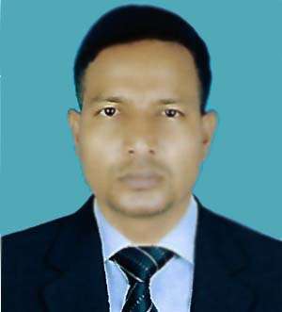

Resume
of

Md. Nurul Islam
Cell: 01818860874

Mailing Address:
Aouch Para
College Get Tongi
Gazipur City Corporation
Gazipur.
E-mail: nurultgc@gmail.com

Career Objective:

Willing to work in challenging and competitive environment where strong sense of responsibility and commitment is required, where dignity of my work provides job satisfaction and the place of work provides for learning growing and achieving of the organization.

Educational Qualification:

Bachelor of Social Science

Group : BSS
Result/GPA : 2nd Division
Board/University : National University
Year of passing : 2004

Higher Secondary Certificate

Group : Humanities
Result/GPA : 2nd Division
Board : Rajshahi
Year of passing : 1998

Secondary School Certificate

Group : Humanities
Result/GPA : 2nd Division
Board : Rajshahi
Year of passing : 1995

Self Motivation:

Ability to manage & work under pressure
Ability to work independently and deal with different level of people
Ability to work in any environment

Computer literacy :

Computer Knowledge (Ms Word, Ms Excel & Power Point, Internet

E-mail, Browsing etc, Adobe Photoshop & Adobe illustrator).

Personal Information:

Father’s Name : Rawsan Ali
Mother’s Name : Tahmina Begum
Permanent Address : Vill: Kathal Bari, P.O- Bhadua
P.S- Pirgonj, Dist- Thakurgaon
Date of Birth : 21 September 1977
Nationality : Bangladeshi (by birth).
Religion : Islam
Marital status : Married
Sex : Male

Md. Nurul Islam
Signature
Date:.

